**Project Design Phase-II**

**Data Flow Diagram & User Stories**

|  |  |
| --- | --- |
| Date | 18-06-2025 |
| Team ID | LTVIP2025TMID46365 |
| Project Name | Book Nest |
| Maximum Marks | 4 Marks |

**Data Flow Diagrams:**

A **Data Flow Diagram (DFD)** illustrates how data moves within the Freelance Finder platform. It captures how users (freelancers and clients) interact with the system, how information flows between different components, and where the data is stored.

Example: DFD Level 0 (Industry Standard)

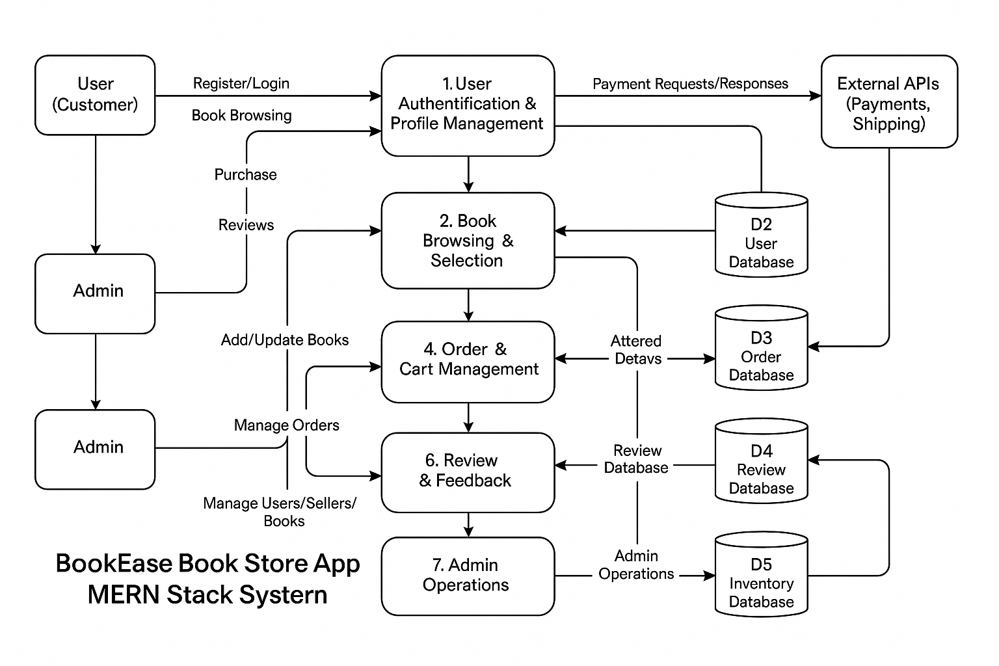

**User Story Table – BookNest App**

|  |  |  |  |  |  |
| --- | --- | --- | --- | --- | --- |
| User Type | Functional Requirement (Epic) | User Story / Task | Acceptance Criteria | Priority | Release |
| User (Reader) | Account Management | As a user, I can register and log in securely. | Account is created and login works correctly. | High | Sprint-1 |
|  | Book Browsing | As a user, I can search for books by title, author, or genre. | Relevant books are shown in the search results. | High | Sprint-1 |
|  | Purchase Books | As a user, I can add books to the cart and make purchases. | Orders are confirmed and inventory updates. | High | Sprint-2 |
|  | Order History | As a user, I can view my order history and details. | Past and current orders display correctly. | Medium | Sprint-2 |
|  | Review System | As a user, I can leave reviews for purchased books. | Reviews appear under respective books. | Medium | Sprint-2 |
|  | Messaging | As a user, I can chat with sellers or support in real-time. | Messages are sent and received instantly. | Medium | Sprint-2 |
| Seller | Inventory Management | As a seller, I can list new books and update stock. | Listings update immediately and reflect in store. | High | Sprint-1 |
|  | Order Fulfillment | As a seller, I can view and manage received orders. | Orders are updated with shipping and status. | High | Sprint-2 |
|  | Profile Management | As a seller, I can update my business profile. | Changes save successfully. | Medium | Sprint-2 |
| Admin | User Management | As an admin, I can manage user and seller accounts. | Admin can create, edit, or deactivate accounts. | High | Sprint-1 |
|  | Book Moderation | As an admin, I can approve or reject book listings. | Only approved books are visible in the store. | High | Sprint-1 |
|  | Review Moderation | As an admin, I can review reported reviews and take actions. | Actions are logged and review status is updated. | Medium | Sprint-2 |
|  | Dashboard Management | As an admin, I can access dashboards for analytics and performance tracking. | Metrics load correctly and update in real-time. | High | Sprint-2 |